**First post**

ABX and objective listening

I would like to share with you a way to train your ears and to compare equipments, mixing techniques as well as undesired effects like clipping.

With the right tools and knowledge we could hope to have more quality music and gears.

You can first practise your ears with heaphone. With your speakers, you will have to deal with the acoustic properties of room too. Once your ears get used to hear what you want switch with your speakers.

If you own the proper equipement you can record your gears : preamplifier, amplifier, cables, DAC, sound cards, etc. and share your files. It could be a good idea to build a database for comparison purpose.

Feel free to add content and correct me if needed. This procedure can be copy, reuse and modify at will, share it with your friends.

**Second post**

Installation procedures

1- In order to do your tests you will need to download Foobar2000 and install it on your computer.

You can find it here :

http://www.foobar2000.org/download

2 - For this exemple we will compare the same file with a different quality and bit rate. so you will have to donwload the Foobar2000's converter pack plugin.

You can find it here :

http://www.foobar2000.org/encoderpack

Once downloaded, you have to install it.

3 - To compare files you will need the Foobar2000's ABX comparator plugin

You can find it here :

http://www.foobar2000.org/components/view/foo_abx

Here's the procedure to install it

Step 1: Open the foobar2000 preferences dialog (click File | Preferences or key CTRL+P).
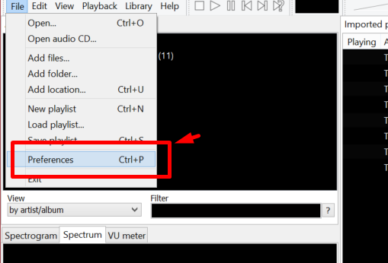
Step 2: Go to the Components page.
Step 3: Click the "Install..." button and select the component archive, or simply drag it to the list.
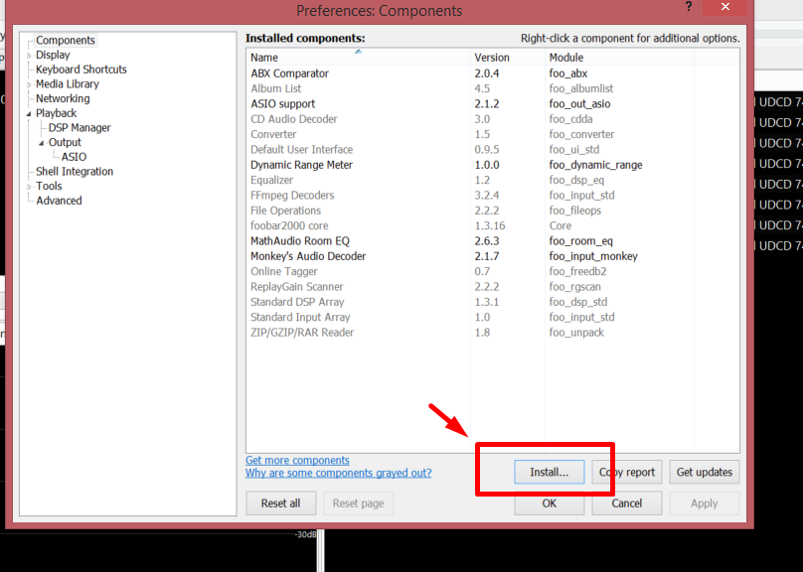
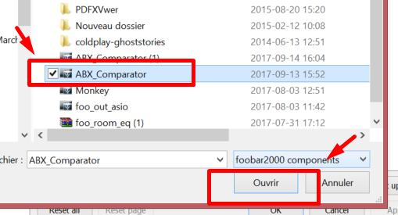
Step 4: Press "OK", you will be prompted to restart foobar2000 in order to load the newly installed component

**third post**

Converting process

You will need a high quality music file, you can use a file you have downloaded from a legal source or rip it from one of your CD.
Open Foobar2000
Click File -> Open -> Choose your music file
Right Click on the file in the playlist menu -> Go to Convert -> Go to ''...'' and click on it
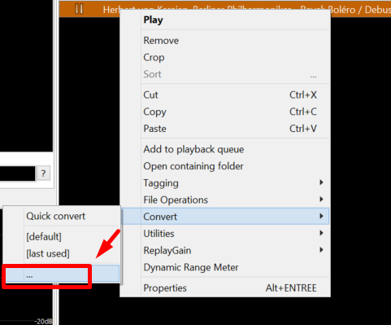

The Converter steup window will appear with four menus
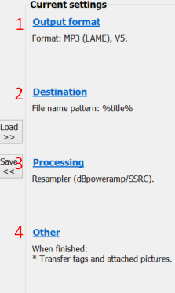
1 - Outpout format
1.1 - Click on Output format -> Choose the output format you want and click Edit (for this exemple we will use MP3).
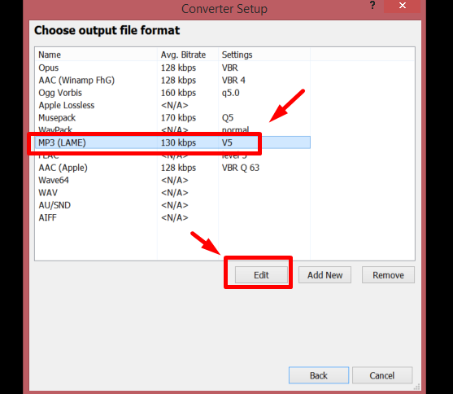
1.2 - Set the quality you want - 130kbps here for our earing test -> Click OK
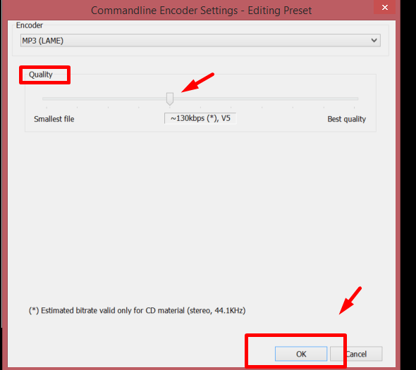
1.3 - Click Back

2 - Destination
You can leave the default settings - Foobar will ask you where you want to save your file when the conversion will be done.

3 - Processing
Now we want to resample the file
3.1 - Click on Processing
3.2 - Choose Resampler (DBpoweramp/SSRC) from the left menu and click on the arrow to load it to the right
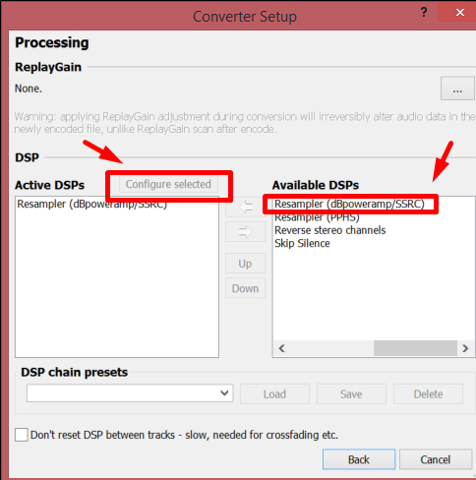
3.3 - Select it in the right menu and Click -> Configure selected
3.4 - Select the desired bit rate - let say 44100 Hz -> Click Ok
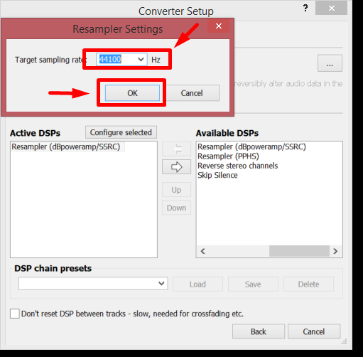
3.5 - Click Back
4 - Other
You can leave this by default.
5 - Click Convert
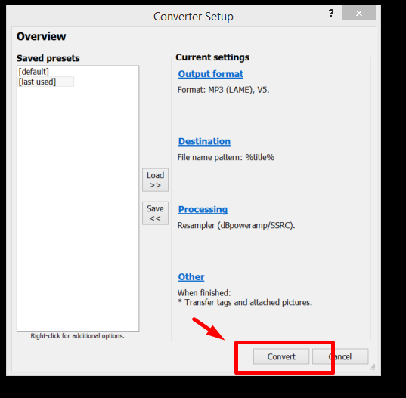
A window will comes up showing the converting progress.
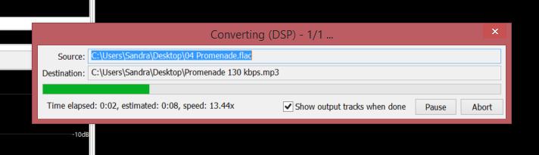
Once finish close the output converter window

**Fourth post**

ABX Comparison

Comparing our files

Click File -> Open... -> Select both files you want to compare.
Make sure both file are selected in the playlist menu - Right Click on tracks -> Go to Utilities -> ABX tracks... and click on it.
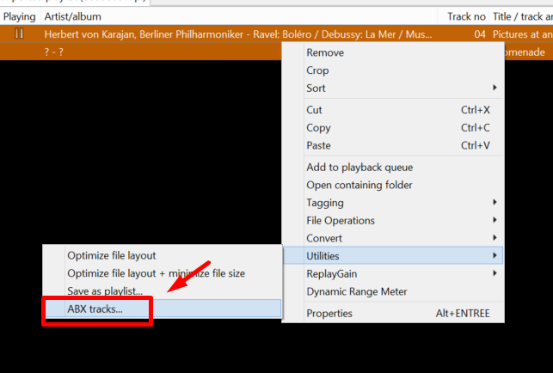

Choose the number of trials you want - Let say 10 for now -> Click Ok.
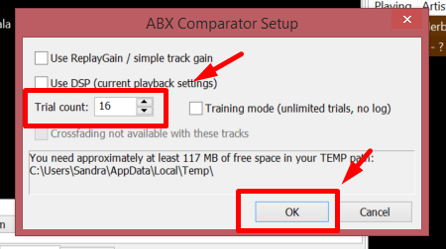

Let's have some fun and start comparing our files.
You can now play the A file and the B file, take your time here and try to identify which one is flac or 130kbps mp3.
Then play the X file and the Y file, you can go back and forth with the A and B file.
Choose in the right menu if ''X is A, Y is B'' or ''Y is A, X is B''.
Click Next trial.
Start again.
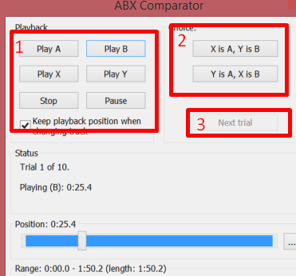
Once all 10 tests are done click -> Finish
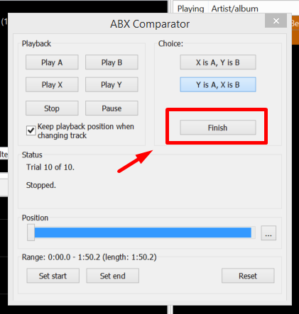
You will now have your log file, you can now -> Save it and share your results here if you want.
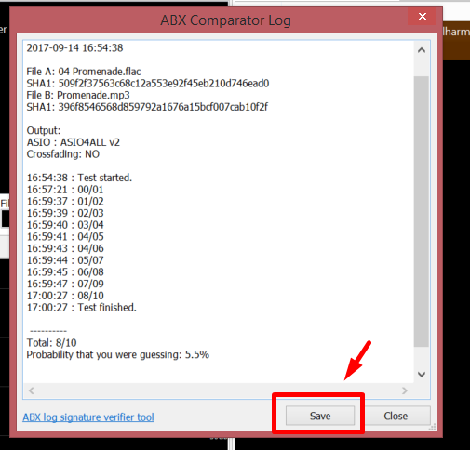

Voila!
Now train your ears and share your results here. There's no shame to fail to identify certain things, there's a lot of marketing hype and a lot of people will make you doubt : if you never heard a X system that worth several thousands dollard you won't never know. Most gears today are transparent and the room's acoustic will have a huge impact on how your speakers sound.
If you know how to read and extract data from manufacturer's specifications you can have a portrait if a gear will affect what you are hearing.

**I will try to give several links to get users informed**

